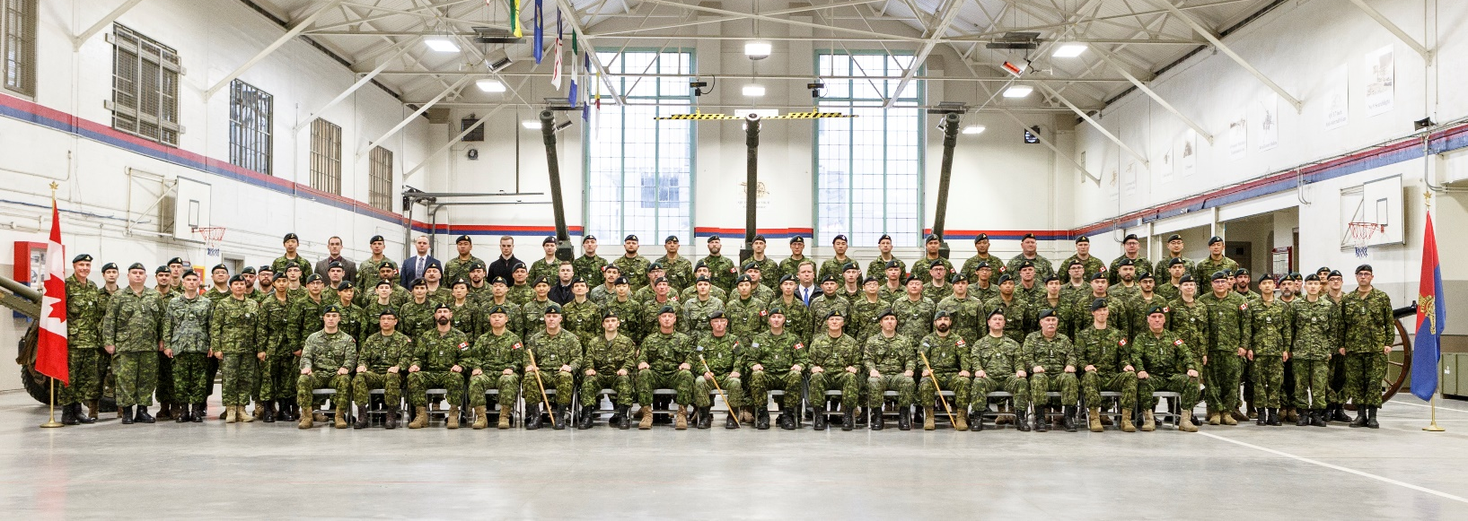
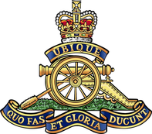
15th Field Artillery Regiment RCA
Soldiers' Christmas Dinner - December 2018
​Back Row - MBdr Evan Huang, Pte Thomas Antrim, Bdr Leiland Lloyd, Gnr Maxwell Massicotte, Gnr Kyle San Juan, Pte Ian Widdows, Cpl Kristin Ranshaw, MBdr Yuriy Bolgak, Bdr Mateuse Soltys, Bdr Safar Alikhanii, Bdr Andrew Clark, MCpl Marc Leclerc, Bdr Andrew Chan, 14, Bdr Peter Gal, Bdr Samuel David, Bdr Mark Magtibay, Bdr Rob Stone, MBdr Benjamin Trivers, Bdr Malcolm Sings, Bdr Tian Wang, MBdr Steven Huang.
Third Row - Sgt Donato Calogero, 2Lt Zachary Caterini, Sgt Dan Scott, Sgt Eric Wong, Sgt Kyle Hodgson, Sgt Ryan Crawford, Bdr Bojan Aleksic, Bdr Guillaume Lahaye, Bdr Inderpal Dhugga, Gnr Joshua Langan, MBdr Xavier Dandurand, Bdr Hugh Kendall, Pte Timothy Kwalheim, Bdr Terrence McGee, MBdr Mackenzie Wilkie, Bdr Robbie Cavanagh, Bdr Oswin Kramer, Pte(R) Wayne Ablitt, Pte Cole Steele, Bdr Brent Nelson, Bdr Cary McCaffery, Bdr Andy Law, Bdr Andrew Voth, Bdr Nathan Patch, Bdr Min Kwoun Kim, Gnr Antonio Campos, Sgt Yves-Andre Langlois, Sgt Ken Keene, WO Dwayne Nelson, Capt George Dempsey, 2Lt Massoud Farahbakhsh, 2Lt Chris Life.
Second Row - Capt Don Lamb, MWO Ken Surges, Sgt Brenda Woods, Bdr Darryn Lacomel, MBdr Joseph Rozario, Bdr Monika Soltys, MBdr Melissa Sumpton, Bdr Alison Cole, Bdr Tracy Gu, Bdr Tiffany Hillier, MBdr Kazue Maruyama, Bdr Tiffany Drew, Cpl Kai Yuan Li, Sgt Stephan Hilbich, Bdr Jessica Deacon, Gnr Jiyeon Lee, Bdr Amiel Ma, MBdr Dan Taylor, Bdr Gary Tse, Bdr Brian Smith, Bdr Xavier Tintinger, Roman Isaac, Bdr Jenn Charters, Bdr David Pare, Bdr Zeshan Syed, MBdr Starr Switzer, MBdr Stephan Figueroa, Sgt Michael Wong, Sgt Jennifer Wong, Capt Isaak Skuce.
​Front Row - Lt Chris Purdon, Capt Conway Hui, WO Adam Wieranga, Capt James Koh, MWO Heath Porritt, Maj Andrew Grieve, Maj Nick Watts, RSM CWO Rob Garrett, CO LCol Pierre Lajoie, HLCol Don Foster, Maj Ian Watt, WO Goran Kurtagic, MWO Angus Brady, Capt Kevin Walker, Capt James Morrison, Capt Rob Wishnicki

Fantastic feedback on the names! We’re just missing #14!
Online viewing can be found at https://www.vancouvergunners.ca/group-photos.html
Contact president.vcrgunners@gmail.com if you can identify him!

PS – You can also let me know if you spot any other errors or omissions!

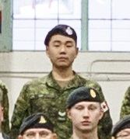

UBIQUE
QUO FAS ET GLORIA DUCUNT

